CS570
Analysis of Algorithms
Fall 2011
Exam II

Name: _____________________
Student ID: _________________
_____12:30 PM Session _____ 2:00 PM Session

 | Maximum | Received
Problem 1 | 20
Problem 2 | 10
Problem 3 | 10
Problem 4 | 20
Problem 5 | 20
Problem 6 | 20
Total | 100

2 hr exam
Close book and notes

If a description to an algorithm is required please limit your description to within 150 words, anything beyond 150 words will not be considered.
- 20 pts
Mark the following statements as TRUE or FALSE. No need to provide any justification.
[ TRUE/FALSE ]
Maximum value of an s-t flow could be less than the capacity of a given s-t cut in a flow network.

[ TRUE/FALSE ]
In a flow network, if we increase the capacity of an edge that happens to be on a minimum cut, this will increase the max flow in the network .
[ TRUE/FALSE ]
The best worst-case time complexity to solve the max flow problem is O(Cm) where C is the total capacity of the edges leaving the source and m is the number of edges in the network.

[ TRUE/FALSE ]
Bellman-Ford algorithm cannot solve the shortest path problem in graphs with negative cost edges in polynomial time.

[ TRUE/FALSE ]
If a dynamic programming solution is set up correctly, i.e. the recurrence equation is correct and the sub-problems are always smaller than the original problem, then the resulting algorithm will always find the optimal solution in polynomial time.

[ TRUE/FALSE ]
If a problem can be solved by dynamic programming, then it can always be solved by exhaustive search.

[ TRUE/FALSE ]
Fractional knapsack problem has a polynomial time greedy solution.

[ TRUE/FALSE ]
0/1 knapsack problem can be solved using dynamic programming in polynomial time.
[ TRUE/FALSE ]
A flow network with unique edge capacities has a unique min cut.

[ TRUE/FALSE ]
The number of iterations it takes Bellman-Ford to converge can vary depending on the order of nodes updated within each iteration.

- 10 pts
You are given a network with n vertices, m edges, a source s and a sink t. Suppose your friend presents to you an s-t flow for the network by assigning for every edge e, a flow f(e). Describe an O(n + m) algorithm to test if your friend's flow assignment is a maximum s-t flow.

- 10 pts
You have successfully computed a maximum s-t flow f for a network G = (V;E) with integer edge capacities. Your boss now gives you another network G’ that is identical to G except that the capacity of exactly one edge is increased by one. You are also explicitly given the edge who's capacity was changed. Describe how you can compute a maximum flow for G’ in O(|V| + |E|) time, where |V | is the number of vertices and |E| is the number of edges.

- 20 pts
Given a weighted directed graph, describe an algorithm that decides if there exists a negative weight cycle in the graph. The running time should be polynomial in the number of vertices.

- 20 pts
We are given a string S = s₁s₂s₃…s_{n}, and we want to delete some characters such that what remains is a palindrome. Give an efficient dynamic programming algorithm to determine the length of the longest palindrome, and analyze the running time.
A palindrome is a string that reads the same backward or forward such as ACCBCCA.

- 20 pts
Determine if there is a feasible circulation in the following network. Demand values are in circles. Edge capacities are marked on each edge.
Show all your steps.

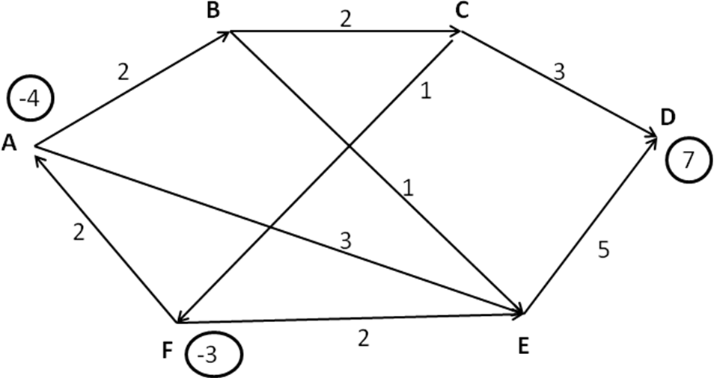

Additional Space

Additional Space

